Developers Guide:
1. Setting up the Hardware:
1. Remove rubber bands
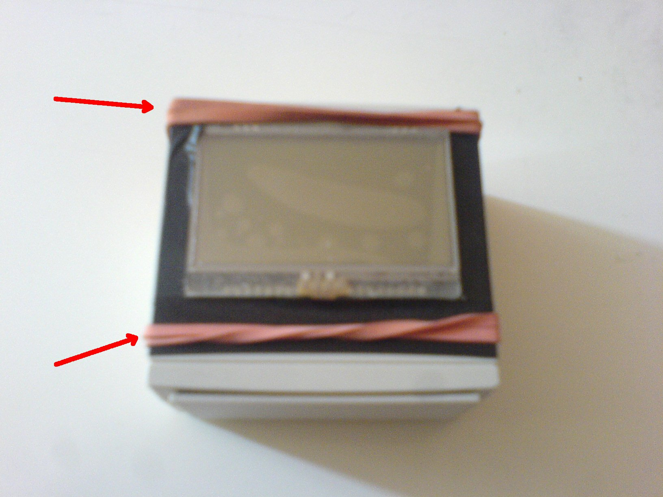
2. Open the device
3. Remove clips and connector
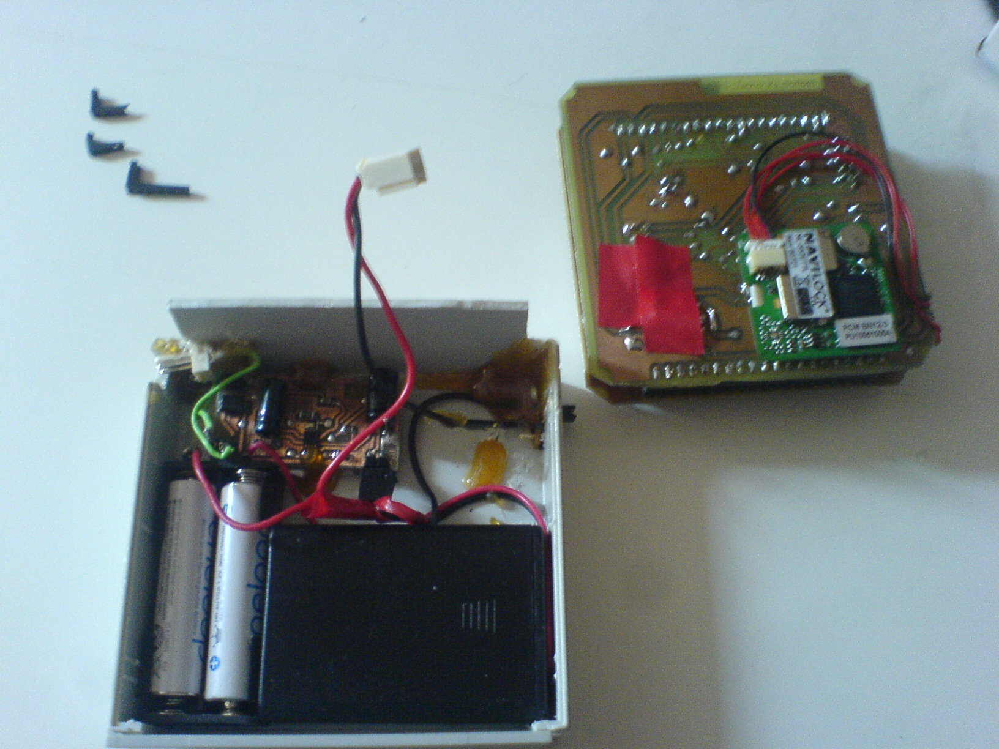
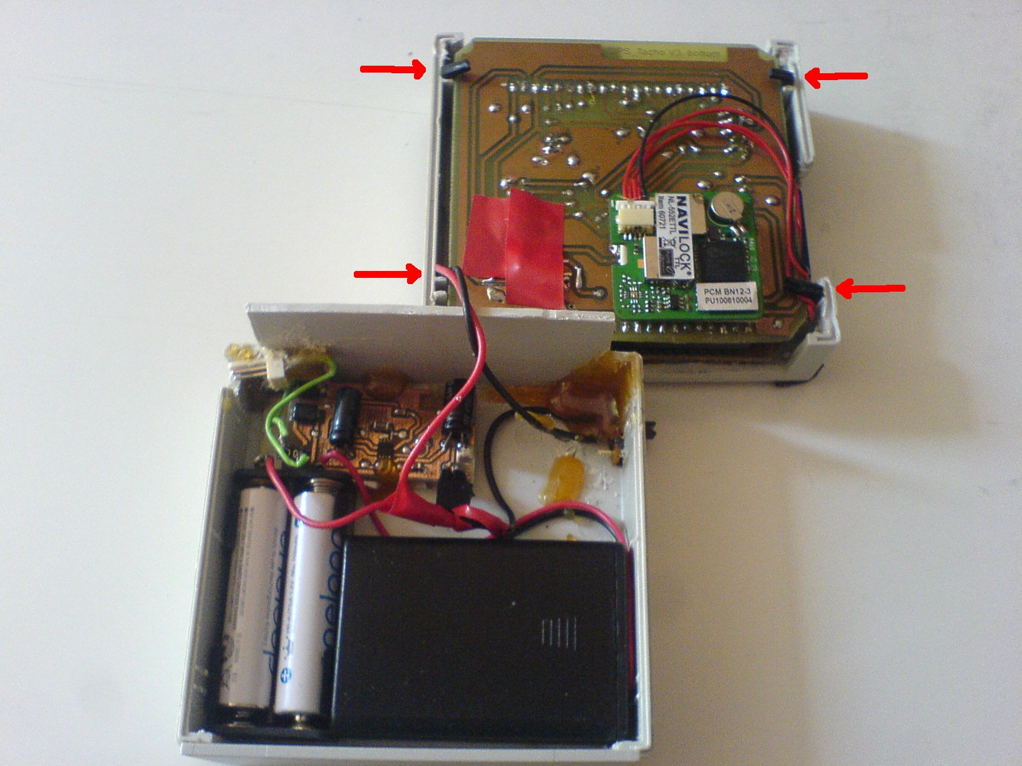
4. plug in external supply voltage and programming device.
Be absolutely sure that the black cable is – and the yellow one is +!
Supply voltages 5.5 V – 9 V.
Next to the SD Slot is the ISP connector. Next to the voltage jack is the JTAG connector.
For JTAG a JTAG controller is needed who is compliant with the ATMega644.
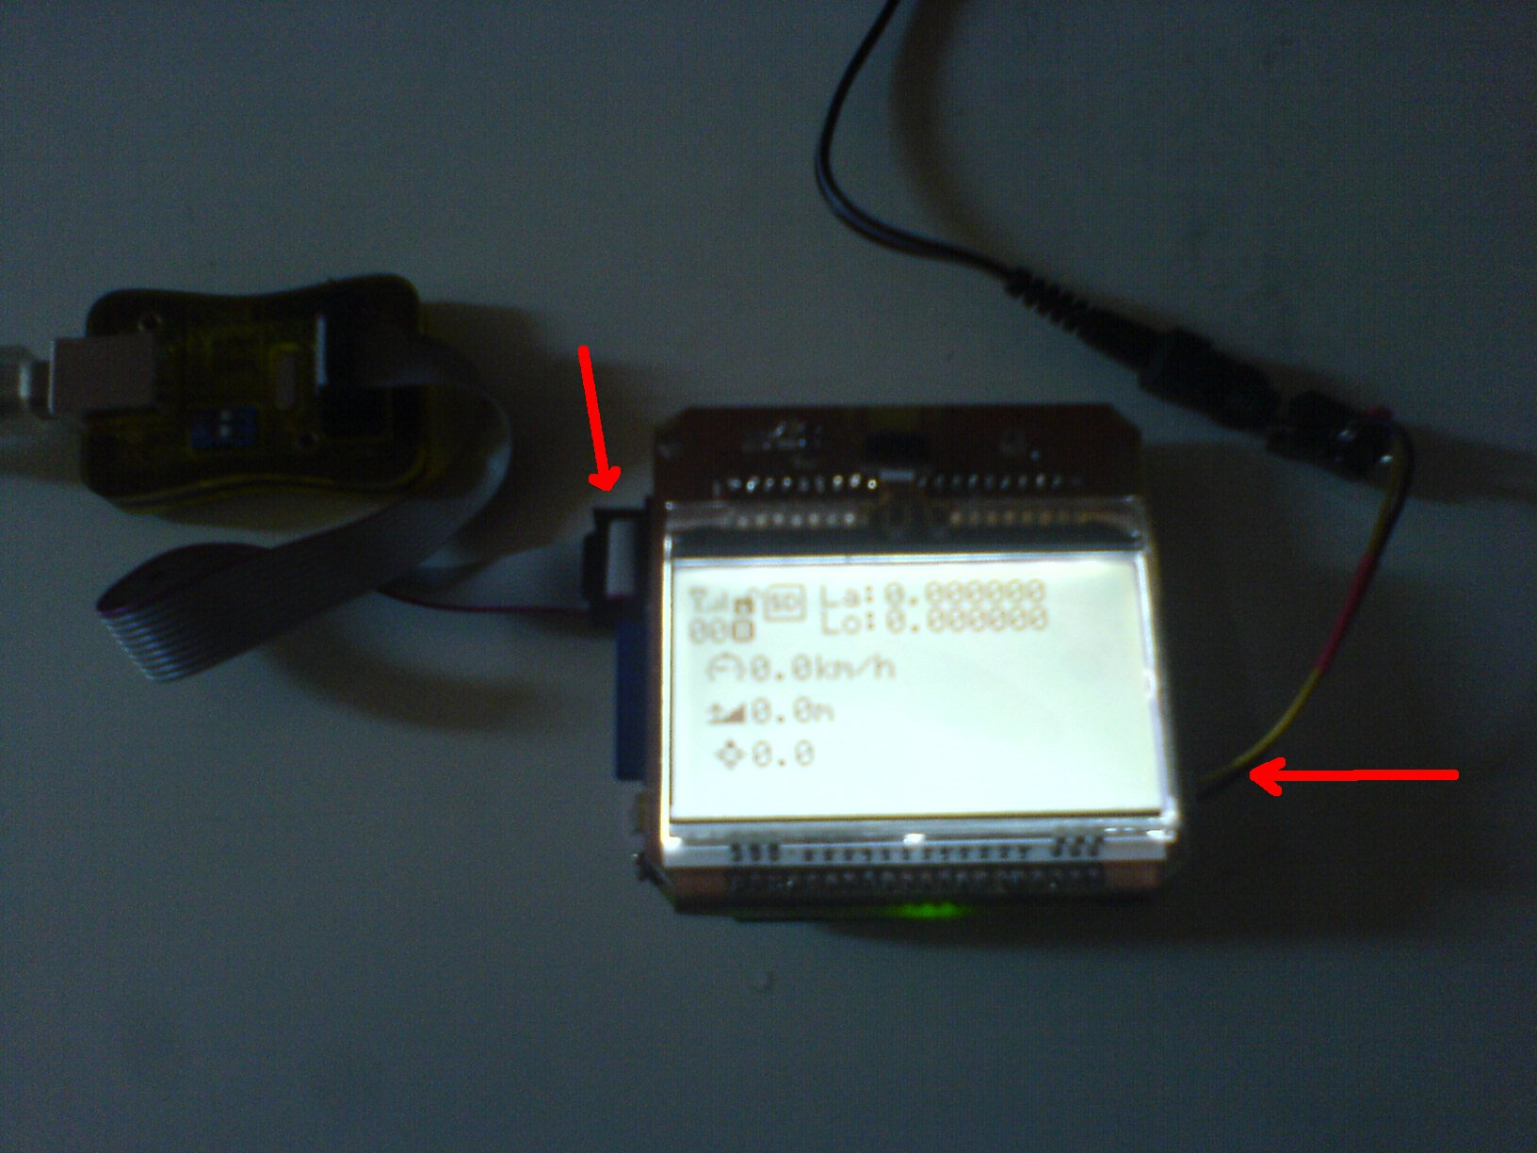
2. Software Setup:
Exctract the Linux Image debian.rar provided on the DVD
Get Virtualbox:
http://www.virtualbox.org/wiki/Downloads
and set up Virtualbox with the provided Linux Image,
Set up a Filter for the ISP or JTAG Programmer
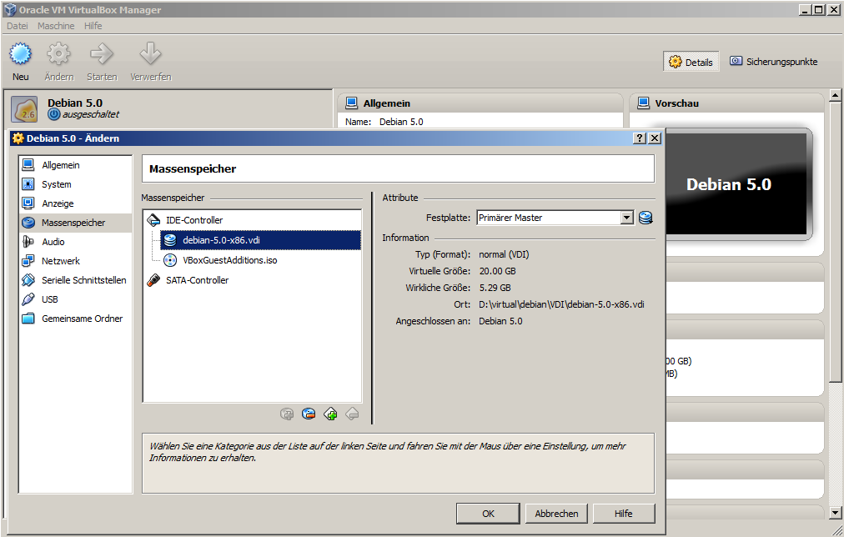
Boot the Linux Image and login with user dev
user: dev, password: dev, root: linux
You will find the source in the home directory of user dev
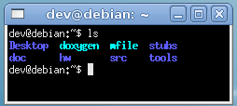
src contains the source code
hw contains hardware circuit and layout files
doc contains the documentation of the project
doxygen contains the API documentation
tools contains some tools used
stubs contains some code stubs
mfile is a program that creates initial Makefiles
Plug in the ISP Programmer
Virtualbox should connect it automatically due to the filter
With the Strange Distribution Diamex ISP Programmer the device is /dev/ttyACM0
If you are not using the Diamex DX-10 ISP Programmer you need to make changes in src/Makefile with the AVRDUDE_PORT and the AVR_DUDEPROGRAMMER
Note: See avrdude manpage which protocol you need for your programmer
'cd ~/src' and 'make'
The whole source tree is built and if successfully compiled the binary will device will be programmed
After make has sucessfully built the source and programmed the device it gives the following messages
If you get an error like this check the permissions of the programmer for your user
If you get errors like this be sure if the target does not have any short circuits
If you get errors like this be sure if the target is connected to the supply voltage
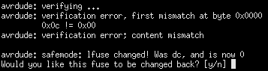
If you get errors like this the ISP Programmer needs to be rest. In order to do that just unplug and reconnect it to the computer
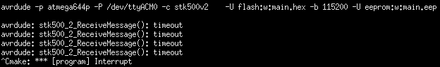
If you get errors like this make sure the programmer is connected to the computer and the AVRDUDE_PORT is correct in the Makefile
If you get errors like this make sure the AVRDUDE_PROGRAMMER is correct in the Makefile
Without errors the device is now successfully programmed
NOTE: We only support the Diamex DX-10 ISP Programmer. Other ISP or JTAG programmers are untested but should work just fine.

